苏州大学实验报告
院系 | 计算机学院 |  | 年级专业 |  | 21计科 |  | 姓名 | 方浩楠 | 学号 | 2127405048
课程名称 |  | 大数据管理 |  |  |  |  |  |  | 成绩
指导教师 |  | 王晶晶 |  | 同组实验者 |  | 无 |  | 实验日期 | 2024.4.18

实 验 名 称 | 实验3: 借助开源TensorFlow工具的词向量训练

- 实验目的
借助开源TensorFlow工具的词向量训练
1. 对 THE TRAGEDY OF ROMEO AND JULIET (罗密欧 与朱丽叶)英文小说中词进行word Embedding训练，获得每个词的向量表示。（word Embedding获得可以调用TensorFlow包）
2. 功能：输入“ROMEO”单词，输出获得5个与其最相似的词（降序排列）及其向量值，例如：juliet，[0.1,0.2]

- 实验内容
利用TensorFlow进行《罗密欧与朱丽叶》文本的词向量训练及相似词查找

- 实验步骤和结果
实验环境:
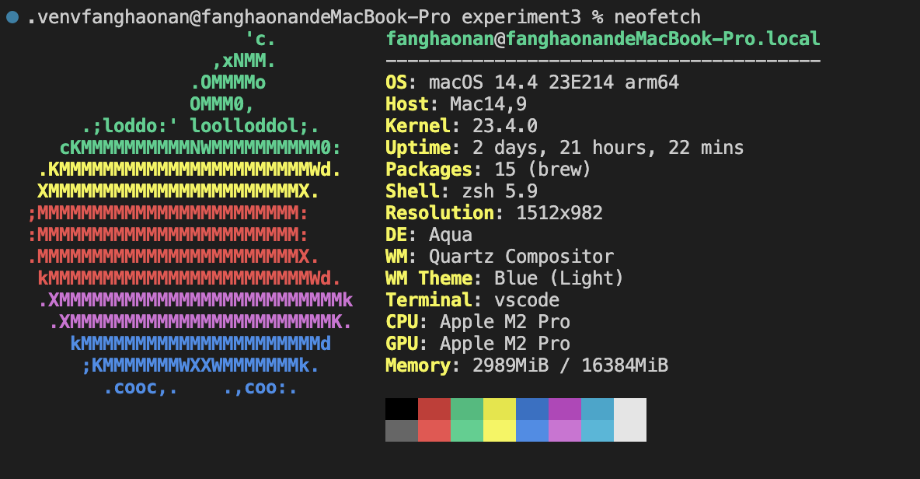
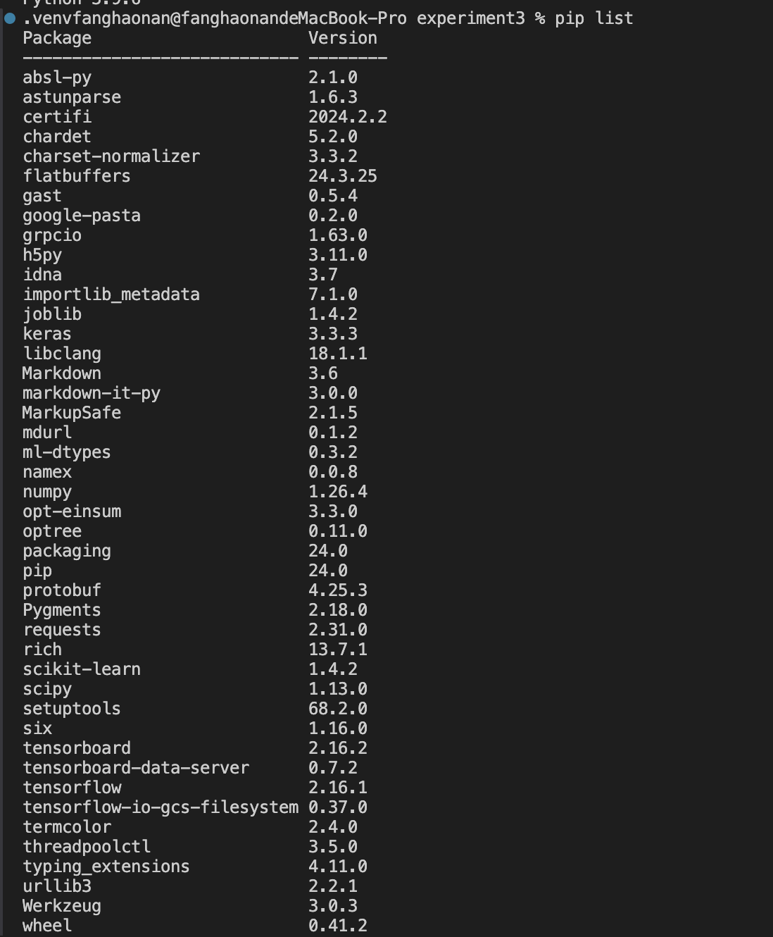
requirements.txt中的内容:
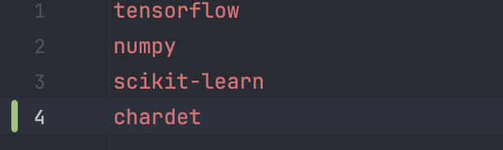
运行项目之前,安装项目所需要的包:
pip install -r requirements.txt
项目结构图:
(.venv) fanghaonan@fanghaonandeMacBook-Pro experiment3 % tree .
.
├── data
│ ├── convert_encoding.py
│ ├── preprocessed_data.pkl
│ ├── romeo_and_juliet.txt
│ ├── word2vec_model.h5
│ └── word_vectors.npy
├── main.py
├── requirements.txt
├── scripts
│ ├── find_similar.py
│ ├── preprocess.py
│ └── train_model.py
├── 实验报告模板.docx
└── 实验要求.md

3 directories, 13 files

首先,由于下载的罗密欧与朱丽叶的txt文件的编码方式不是UTF-8,因此编写代码来修改txt文件的编码格式:
convert_encoding.py:
import chardet

# 检查文件编码
with open('romeo_and_juliet.txt', 'rb') as f:
raw_data = f.read()
result = chardet.detect(raw_data)
encoding = result['encoding']
print(f"File encoding: {encoding}")

# 转换为 utf-8 编码
if encoding.lower() != 'utf-8':
with open('romeo_and_juliet.txt', 'r', encoding=encoding) as f:
text = f.read()
with open('romeo_and_juliet.txt', 'w', encoding='utf-8') as f:
f.write(text)
print("File has been converted to utf-8 encoding")

然后进行数据预处理, 在scripts/preprocess.py中进行数据预处理，读取文本文件并进行清理和标记。
preprocess.py:
import re
import string
from collections import Counter
from tensorflow.keras.preprocessing.text import Tokenizer
import sys
import pickle

def preprocess_text(file_path: str) -> tuple[list, dict, int]:
with open(file_path, 'r', encoding='utf-8') as file:
text = file.read()

text = text.lower()
text = re.sub(r'[%s]' % re.escape(string.punctuation), '', text)
words = text.split()

word_counts = Counter(words)
words = [word for word in words if word_counts[word] > 1]

tokenizer = Tokenizer()
tokenizer.fit_on_texts([words])
sequences = tokenizer.texts_to_sequences([words])[0]
word_index = tokenizer.word_index

vocab_size = len(word_index) + 1

return sequences, word_index, vocab_size

if __name__ == "__main__":
input_file = sys.argv[1]
output_file = sys.argv[2]
sequences, word_index, vocab_size = preprocess_text(input_file)

with open(output_file, 'wb') as f:
pickle.dump((sequences, word_index, vocab_size), f)

训练词向量模型:
在scripts/train_model.py中进行词向量模型的训练。
train_model.py:
import tensorflow as tf
import numpy as np
import pickle
import sys
from typing import List, Tuple, Dict

def generate_skipgram_data(sequences: List[int], window_size: int, vocab_size: int) -> Tuple[np.ndarray, np.ndarray]:
couples: List[List[int]] = []
labels: List[int] = []
for i, word_id in enumerate(sequences):
start = max(0, i - window_size)
end = min(len(sequences), i + window_size + 1)
for j in range(start, end):
if i != j:
couples.append([word_id, sequences[j]])
labels.append(1)
return np.array(couples), np.array(labels)

if __name__ == "__main__":
input_file: str = sys.argv[1]
model_file: str = sys.argv[2]
vectors_file: str = sys.argv[3]

with open(input_file, 'rb') as f:
sequences, word_index, vocab_size = pickle.load(f)

sequences: List[int]
word_index: Dict[str, int]
vocab_size: int

window_size: int = 2
couples, labels = generate_skipgram_data(sequences, window_size, vocab_size)

print(f"Number of training samples: {len(couples)}")
print(f"First 5 couples: {couples[:5]}")

if couples.size == 0:
raise ValueError("No training data generated. Check your data and preprocessing steps.")

embedding_dim: int = 100

target_input = tf.keras.layers.Input(shape=(1,), dtype='int32')
context_input = tf.keras.layers.Input(shape=(1,), dtype='int32')

embedding = tf.keras.layers.Embedding(input_dim=vocab_size, output_dim=embedding_dim, name='embedding')
target_embedding = embedding(target_input)
context_embedding = embedding(context_input)

dot_product = tf.keras.layers.Dot(axes=-1)([target_embedding, context_embedding])
dot_product = tf.keras.layers.Reshape((1,))(dot_product)
output = tf.keras.layers.Dense(1, activation='sigmoid')(dot_product)

model = tf.keras.models.Model(inputs=[target_input, context_input], outputs=output)
model.compile(loss='binary_crossentropy', optimizer='adam')

model.fit([couples[:, 0], couples[:, 1]], labels, epochs=5, batch_size=64)

model.save(model_file)
np.save(vectors_file, model.get_layer('embedding').get_weights()[0])

查找相似词

在scripts/find_similar.py中实现查找与特定单词最相似的词及其向量值。
ind_similar.py:
import numpy as np
from sklearn.metrics.pairwise import cosine_similarity
import pickle
import sys

if __name__ == "__main__":
input_file = sys.argv[1]
vectors_file = sys.argv[2]

with open(input_file, 'rb') as f:
sequences, word_index, vocab_size = pickle.load(f)

word_vectors = np.load(vectors_file)

def find_similar_words(target_word, word_index, word_vectors, top_n=5):
target_index = word_index.get(target_word)
if not target_index:
return []

target_vector = word_vectors[target_index].reshape(1, -1)
similarities = cosine_similarity(target_vector, word_vectors)[0]

similar_indices = similarities.argsort()[-top_n-1:-1][::-1]
similar_words = [(word, similarities[index]) for word, index in word_index.items() if index in similar_indices]

return similar_words

similar_words = find_similar_words('romeo', word_index, word_vectors)

for word, similarity in similar_words:
print(f"Word: {word}, Similarity: {similarity}, Vector: {word_vectors[word_index[word]]}")

然后运行main.py:
main.py:
import os

if __name__ == "__main__":
project_dir = os.path.dirname(os.path.abspath(__file__))
data_dir = os.path.join(project_dir, 'data')
scripts_dir = os.path.join(project_dir, 'scripts')

# 预处理
os.system(f'python {scripts_dir}/preprocess.py {data_dir}/romeo_and_juliet.txt {data_dir}/preprocessed_data.pkl')

# 训练模型
os.system(f'python {scripts_dir}/train_model.py {data_dir}/preprocessed_data.pkl {data_dir}/word2vec_model.h5 {data_dir}/word_vectors.npy')

# 查找相似词
os.system(f'python {scripts_dir}/find_similar.py {data_dir}/preprocessed_data.pkl {data_dir}/word_vectors.npy')

运行结果:
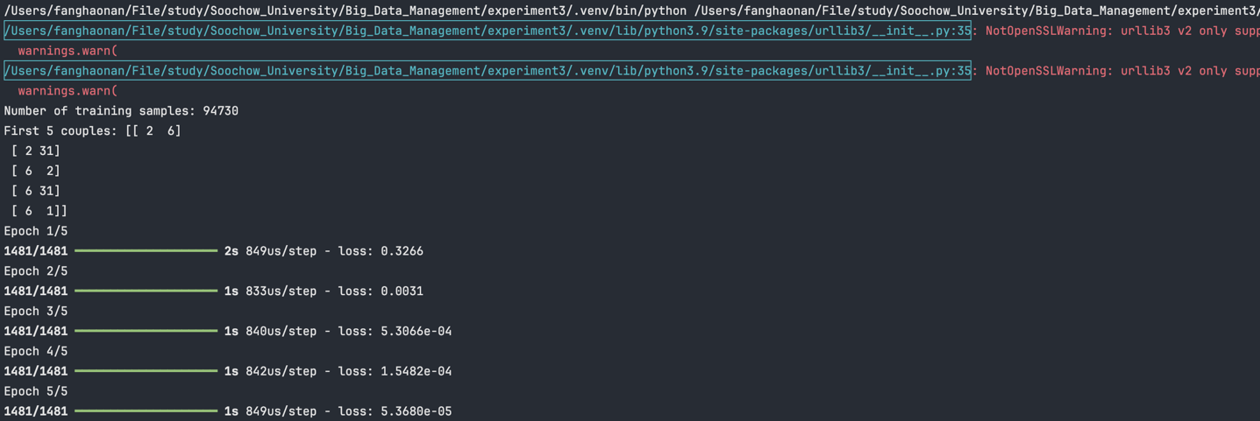
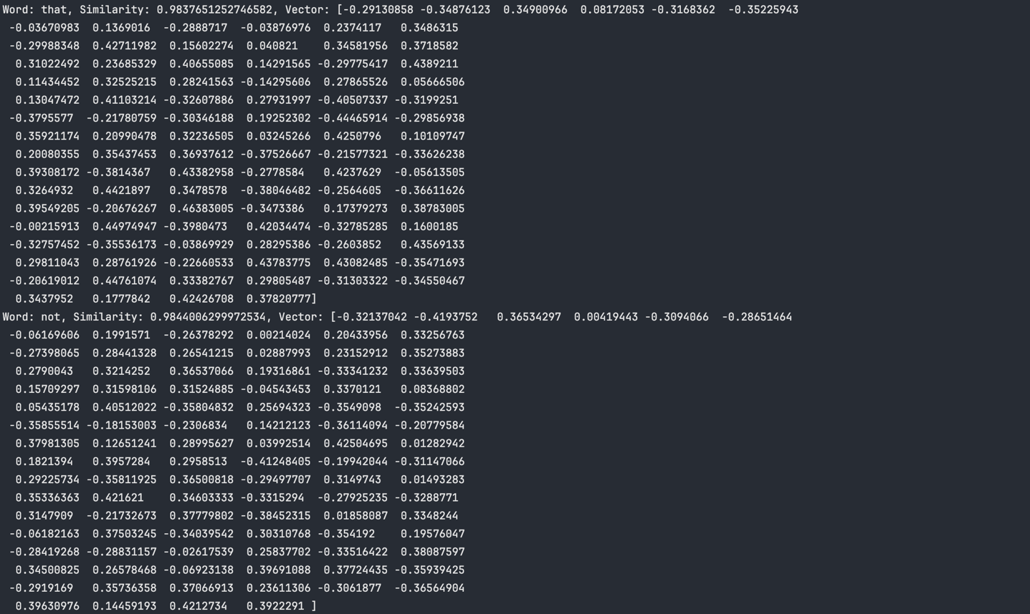
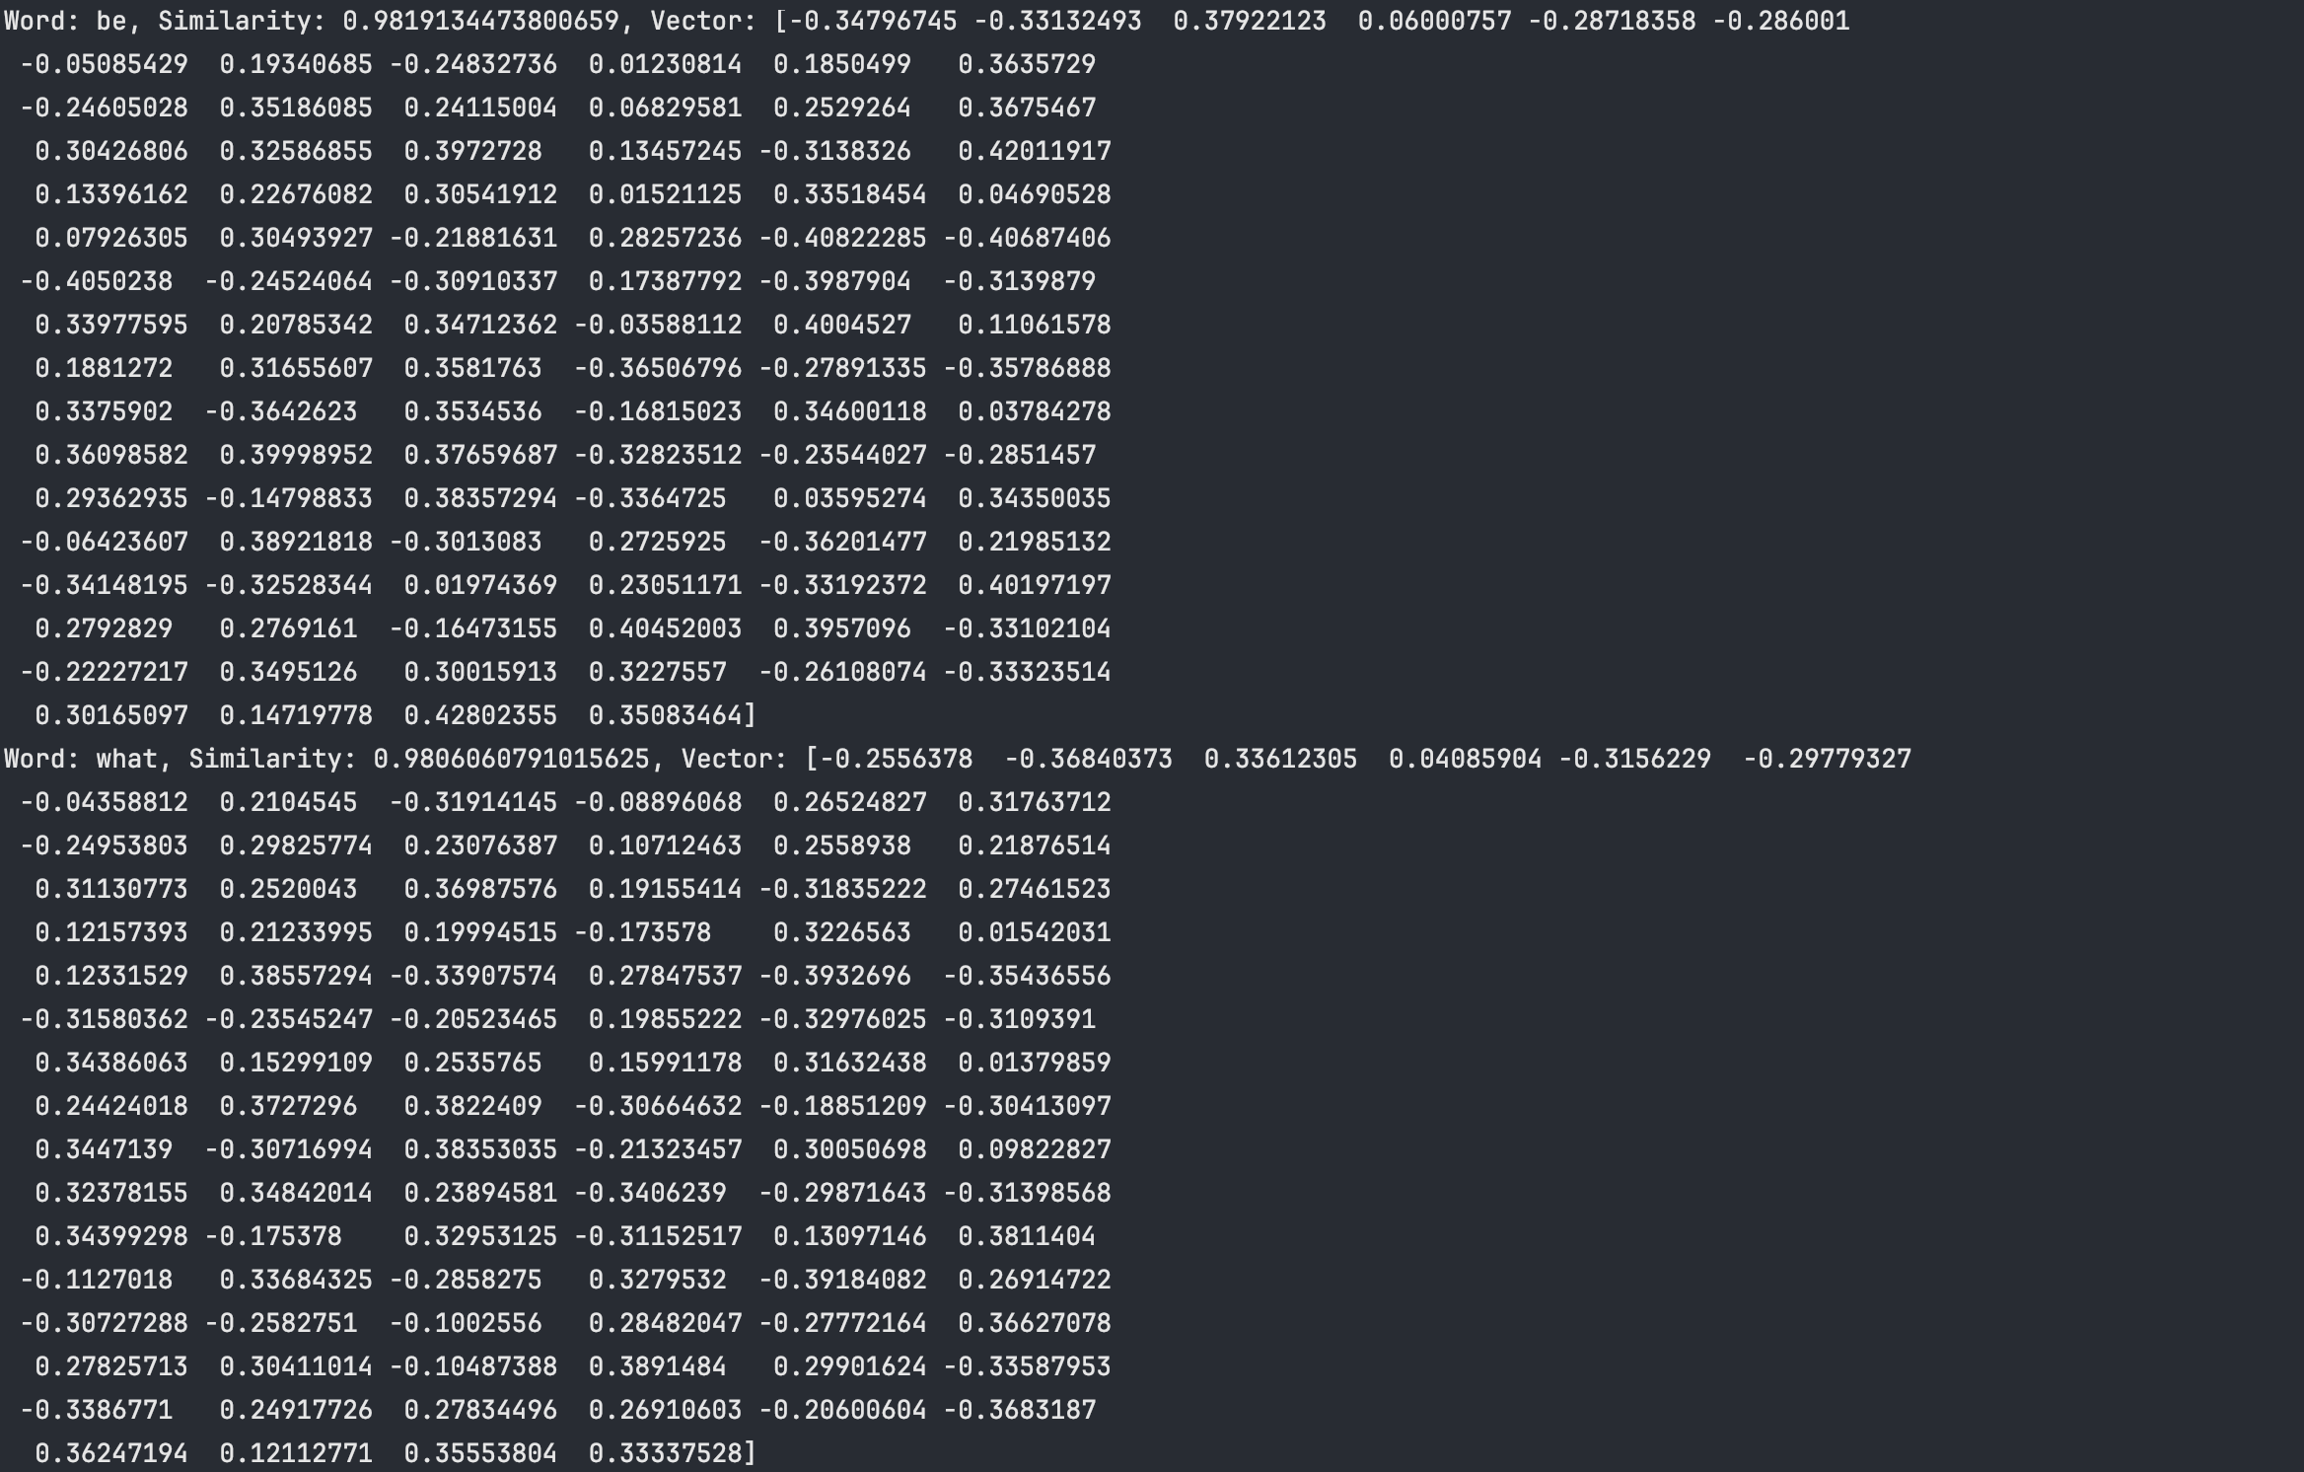
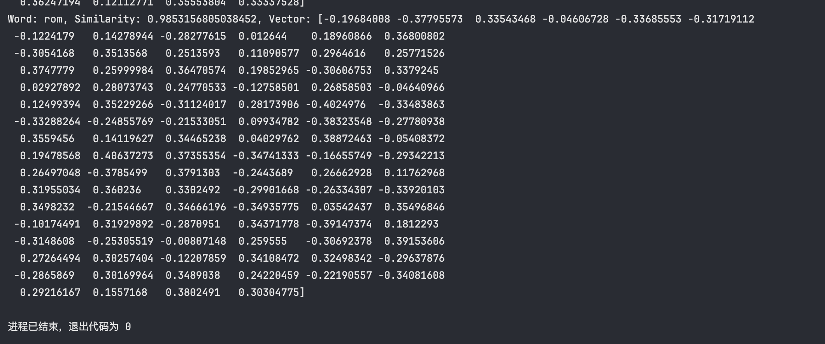

- 实验总结
通过本次实验，我学习了如何利用TensorFlow进行文本的词向量训练，并实现了查找与特定单词最相似的词及其向量值的功能。实验结果显示，模型能够成功地找到与输入单词最相似的词，并输出其向量值。这为进一步的自然语言处理和文本分析提供了基础。

